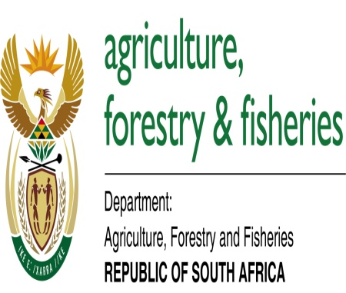

LandCare increase the yields of the farmers through CA approach

Conservation Agriculture has its origin in conservation tillage, which was developed to respond to the dramatic degradation of agricultural production resources. This was mainly soil erosion through wind and rain water impact. Closely connected to soil is the water resource, which is also addressed by Conservation Agriculture and is of particular importance for dry lands. In that respect the ‘‘in-field’’ water management aspects are also addressed here. Reducing the intensity of tillage for economic reasons (leading to minimum tillage) or for environmental reasons (leading to conservation tillage and finally to zero tillage practices) is not a new idea. One of the first references in modern agriculture to no-till farming is probably Edward Faulkner’s “Ploughman’s Folly” (1945). Over the last few decades, the practice of minimum and no-tillage had its ups and downs. Minimum tillage, conservation tillage and zero tillage were all applied as practices within conventional concepts of agriculture and therefore were not universally applicable.

Conservation Agriculture (CA) is defined as a concept for resource-saving agricultural crop production that strives to achieve acceptable profits and high and sustained production levels while concurrently conserving the environment. It is regarded as a sustainable land management tool for agricultural lands. CA is based on enhancing natural biological processes above and below the ground. Interventions such as mechanical soil tillage are reduced to an absolute minimum and the use of external inputs such as agrochemicals and nutrients of mineral or organic origin are applied at an optimum level and in a way and quantity that does not interfere with or disrupt the biological processes. In some cases, external inputs are reduced to zero. CA is characterised by three principles which are linked to each other, namely: minimum mechanical soil disturbance throughout the entire crop rotation, permanent organic soil cover, diversified crop rotations in case of annual crops or plant associations in case of perennial crops.

With the increased adoption of Conservation Agriculture, the experience with the system grew and other implications and benefits were noted. These benefits impact directly on the livelihoods of the farmer through the effect on profitability of farming and especially the largely reduced labour requirements. Particularly for a small scale family farm and vulnerable households with limited labour resources, the introduction of Conservation Agriculture can lead to significant improvements in the livelihoods through stabilising the natural resource base and at the same contributing to more stable yields, even in drought affected years. By changing some key operations, the approach has also had an impact on the agricultural mechanization and the equipment choices and therefore influences the agricultural machinery supply sector in the long term. Dealers and sales points in rural areas will likely be encouraged to adjust their outlets if increased demand for CA relevant equipment gets more evident.

The Department of Agriculture, Forestry and Fisheries through the LandCare programme support this CA initiative by providing conditional grants to provinces for implementation, to address improved food security and sustain natural resources at the community setup.

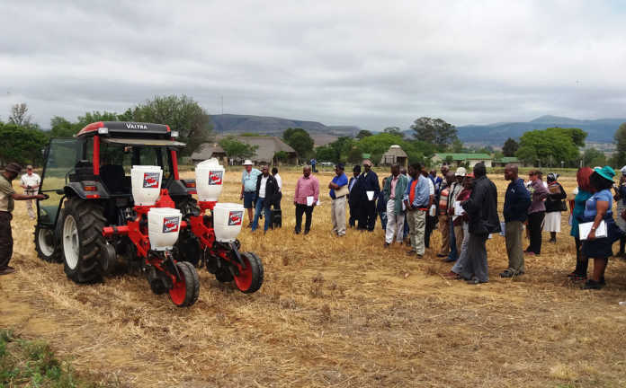
.
For more information, visit www.daff.gov.za.

